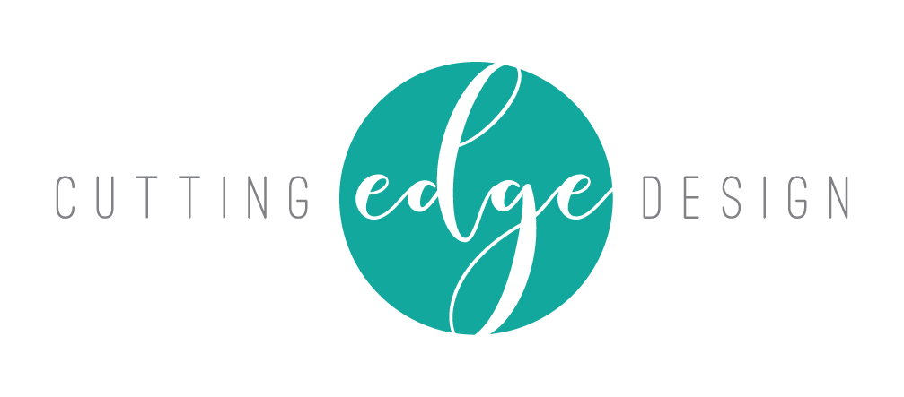

LOGO DESIGN BRIEF:

There are certain questions I like to ask a client prior to beginning the logo design process, to ensure good, clear communication. It may seem like a long list but it helps me to know what your needs are and what you expect from your finished logo/branding. It also helps to clarify your own vision for your business branding.

YOUR BUSINESS

What is the name of your business?

Describe in your business/service.

If you are not a new business start-up – what are the reasons you want a new logo?

Who are your main competitors and how do you differ from them?

What do you like or dislike about your competitor’s branding?

Who are your potential clients?

YOUR LOGO

Do you have a specific idea in mind for your logo?

Do you want to use existing brand colours or a particular range of colours?

Are there any colors that you do not want to use?

Do you have a particular font you would like to use – or ones you definitely do not want to use?

What words should describe your logo?

What message or emotion do you want your logo to portray?

Does your business have a tag line?

What logos do you like and why? And if you can email me some ones you like that would be great.

Any other comments?

